
Veronica Garcia
Workers’ Compensation/
Safety Manager

1201 Bryce Drive
Mission, Texas 78572-4399
(956) 323-5545 Office
(956) 323-5526 Fax
E-mail: vgarci41@mcisd.org

Memorandum
To: Carlos Lerma, Director for Transportation
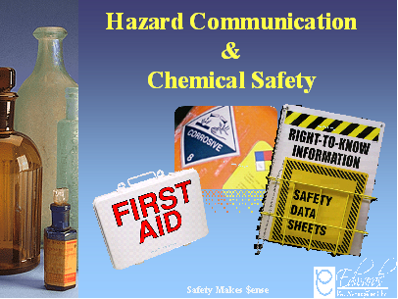
Ricardo Rivera, Executive Dir. for Maintenance, Fac., & Const.
Rosie Woodrum, Director of Food Services
Rene Flores, Coordinator for Fixed Assets
CC: Sylvia Cruz, Coordinator for Risk Management
Date: December 19, 2013
From: Veronica Garcia, W/C & Safety Manager
RE: Mandatory Safety Trainings
Subject: “What is the Globally Harmonized System?
GHS of Classification & Labeling of Chemicals”

Our Worker’s Compensation carrier, Edwards Risk Management, Inc., will be providing the 2nd series of safety trainings for the 2013-2014 school year. The trainings will begin January 14th, 15th, and January 16th. The trainings will be scheduled in the following manner:

Date | Time | Location | Department
January 14, 2014  Tuesday | 8:00 a.m. - 9:00 a.m. | Maintenance Bldg | Custodians – Spanish
 | 9:30 a.m. - 10:30 a.m. | Transportation Portable | Transportation & Fixes Assets - English
 | 11:00 a.m. - 12:00 p.m. | Maintenance Bldg | Custodians– Spanish
 | 1:00 p.m. - 2:00 p.m. | Maintenance Bldg | Maintenance – English
 | 2:30 p.m. - 3:30 p.m. | Central Kitchen | Food Service – Spanish
January 15, 2014  Wednesday | 8:00 a.m. - 9:00 a.m. | Maintenance Bldg | Custodians – English
 | 9:30 a.m. - 10:30 a.m. | Transportation Portable | Transportation & Fixes Assets – Spanish
 | 11:00 a.m. - 12:00 p.m. | Maintenance Bldg | Maintenance – Spanish
 | 2:30 p.m. - 3:30 p.m. | Central Kitchen | Food Service – English
January 16, 2014  Thursday | 8:30 a.m. - 9:30 a.m. | Board Room | Board Room
 | 9:30 a.m. - 10:30 a.m. | Board Room | Board Room
 | 10:30 a.m. - 11:30 a.m. | Board Room | Board Room

